**Table of contents**

1. Task  3

Option 1.  3

Option 2.  3

2. Initial data  4

3. Calculation of a fixed hinged-bolted connection of the "ear-fork" type  6

3.1 Determining the bolt diameter from the shear strength condition  6

3.1.1 Determining the bolt diameter from the condition of shear shear strength (material 30KhGSA)  6

3.1.2 Determining the bolt diameter from the condition of strength according to shear conditions (material 30KhGSA)  8

3.2 Determining the thickness of the lug from the condition of crushing strength  9

3.3 Bolted connection parameters  12

3.4 Dimensioning ( x , y , b ) of lugs from the tensile strength condition  12

3.5 Checking the shear strength of the lugs  16

3.6 Design parameters  18

4. Calculation of the movable connection (with bushings)  19

Mobile connection features  19

4.1 Determining the thickness of the eyelet from the condition of crushing strength  20

4.1.1 According to the inner diameter d (collapse of the sleeve by the bolt)  20

4.1.2 According to the outer diameter D (collapse of the eye by the sleeve)  22

4.2 Bolted connection parameters  24

4.3 Dimensioning ( x , y , b ) of the ear lug from the tensile strength condition  25

4.4 Checking the shear strength of the lug  27

4.5 Design parameters  29

5. Summary table of safety factors  31

6. List of used literature  32

# **1. Task**

The purpose of the work: to develop the design of the hinged-bolted connection of the "ear-fork" type in two versions.

## **Option 1.**

The design of the fixed connection type "ear-plug":

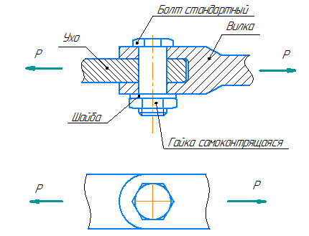

Figure 1.1 Fixed ear-plug connection

## **Option 2.**

The design of the movable connection of the "ear-plug" type with bushings:

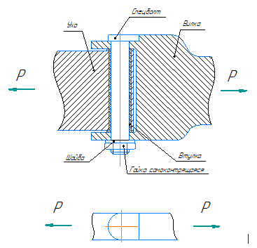

Figure 1.2 Sliding ear-plug

# **2. Initial data**

Option 3

Estimated destructive force acting on the connection:

$$P=17500 даН=175000 Н$$

In this paper, the calculation of a fixed and movable connection with and without bushings is considered.

Ear material: OT4 steel ;

Fork material: steel 30KhGSA;

Bolt complex material: steel 30KhGSA;

Bushing material: steel 30HGSA;

Consider the mechanical properties of materials. Characteristics of titanium alloy OT4 are given in table 2.1:

Tab. 2.1 "Mechanical characteristics OT4"

|  |  |  |
| --- | --- | --- |
| Characteristics | Designation and dimension | OT4 |
| Tensile Strength | σV | 700 MPa |
| Relative elongation after rupture | δ | 12% |
| Tensile modulus | E | 110000 MPa |
| Density | ρ | 4500 $\frac{кг}{м^{3}}$ |
| Specific gravity of the material | $$γ=ρ*g$$ | 44145 $\frac{Н}{м^{3}}$ |
| Shear strength | $$τ_{B}=k{*σ}_{B}$$ | 350 MPa |
| Deformation Limit | $ε_{пр}$ = $\frac{σ_{B}}{E}*100\%$ | 0.64% |
| Specific strength | L= $\frac{σ_{B}}{ϒ}$ | 15.9 km |

$$γ=ρ*g=4500\frac{кг}{м^{3}}*9,81\frac{м}{с^{2}}=44145\frac{Н}{м^{3}};$$

$τ_{B}=k*σ_{B}$;

for OT4 $k=0,5$, Then:

$$τ_{B}=0,5*700 МПа=350 МПа;$$

$$ε_{пр}=\frac{σ_{в}}{E}∙100\%=\frac{700 МПа}{110000 МПа}∙100\%=0,64 \%;$$

$$L=\frac{σ_{B}}{γ}=\frac{700 МПа}{44145\frac{Н}{м^{3}}}=\frac{700*{10}^{6} \frac{Н}{м^{2}}}{44145\frac{Н}{м^{3}}}=15900 м=15,9 км;$$

Mechanical characteristics of 30HGSA are given in Table 2.2:

Tab. 2.2 "Mechanical characteristics of steel 30KhGSA"

|  |  |  |
| --- | --- | --- |
| Characteristics | Designation | Material |
| 30HGSA |
| Tensile modulus (Young's modulus) | E | 210000 $\frac{Н}{{мм}^{2}}$ |
| Shear modulus | G | 80000 $\frac{Н}{{мм}^{2}}$ |
| Material density | ρ | 7850 $\frac{кг}{м^{3}}$ |
| Specific gravity of the material | $$γ=ρ*g$$ | 77009 $\frac{Н}{м^{3}}$ |
| Tensile Strength | $$σ_{B}$$ | 1080 $\frac{Н}{мм^{2}}$ |
| Conditional yield strength | $$σ_{0.2}$$ | 850 $\frac{Н}{{мм}^{2}}$ |
| Shear strength | $$τ_{B}=k*σ_{B}$$ | 648 $\frac{Н}{{мм}^{2}}$ |
| Deformation Limit | $$ε_{пр}=\frac{σ_{в}}{E}∙100\%$$ | 0.51% |
| Specific material strength | $$L=\frac{σ_{B}}{γ}$$ | 14 km |

$$γ=ρ*g=7850\frac{кг}{м^{3}}*9,81\frac{м}{с^{2}}=77009\frac{Н}{м^{3}}$$

$τ_{B}=k*σ_{B}$;

for 30HGSA $k=0,6$, then:

$τ_{B}=0,6*1080 МПа=648 МПа;$

$$ε_{пр}=\frac{σ_{в}}{E}∙100\%=\frac{1080 МПа}{210000 МПа}∙100\%=0,51 \%;$$

$$L=\frac{σ_{B}}{γ}=\frac{1080 МПа}{77009\frac{Н}{м^{3}}}=\frac{1080*{10}^{6} \frac{Н}{м^{2}}}{77009\frac{Н}{м^{3}}}=14024 м=14 км;$$

# **3. Calculation of a fixed hinged-bolted connection of the "ear-fork" type**

Let's calculate the fixed connection.

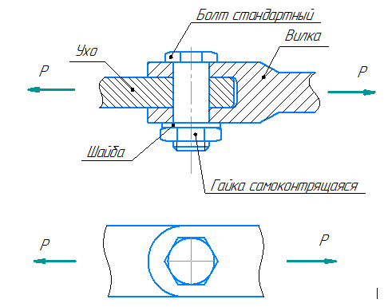

Figure 3.1 Fixed Connection Diagram

## **3.1 Determining the bolt diameter from the shear strength condition**

There are two options for finding the bolt diameter according to shear conditions:

1. By tangential stresses;
2. According to the maximum efforts on the cut;

### **3.1.1 Determination of the bolt diameter from the condition of shear shear strength (material 30KhGSA)**

Let us write down the shear strength condition for shear stresses:

$τ_{ср}≤[τ_{ср}]$, Where

$τ_{ср}$ are the effective shear stresses;

$[τ_{ср}]$– design-destructive shear stresses.

Margin of safety for shear stresses:

$$η=\frac{[{τ_{ср}}_{ }]}{{τ_{ср}}_{ }}≥1;$$

The effective shear stresses are determined by the formula:

$τ_{ср}=\frac{P_{ср}}{F_{ср}}$, Where

- acting shear force;

$F_{ср}$ is the area of the cut.

The connection is double-shear (two bolt shear planes), so the effective shear force will be determined by the formula:

$P_{ср}=\frac{P}{2}$, Where

P is the force acting on the connection, then:

$$P_{ср}=\frac{175000 Н}{2}=87500 Н$$

Since the shank of the bolt has a circular cross section,

$$F_{ср}=\frac{π∙d^{2}}{4};$$

Then:

$$τ_{ср}=\frac{P_{ср}}{F_{ср}}=\frac{P_{ср}}{\frac{π∙d^{2}}{4}}=\frac{{4∙P}_{ср}}{π∙d^{2}};$$

The design-destructive shear stresses are equal to the tensile strength for shear stresses:

$$\left[τ_{ср}\right]=τ_{В};$$

We determine the required bolt diameter by equating the effective and design-destructive stresses:

$$τ_{ср}=\left[τ_{ср}\right];$$

$$\frac{{4∙P}_{ср}}{π∙d^{2}}=τ_{B};$$

Next, we express the required bolt diameter:

$$d≥\sqrt{\frac{{4∙P}_{ср}}{π∙τ_{B}}};$$

Substituting the values into the formula, we get:

$$d≥\sqrt{\frac{4∙87500}{3,14∙648}}=\sqrt{172}=13,11 мм \underset{⇒}{ } d=14 мм;$$

Effective shear stresses:

$$τ_{ср}=\frac{P_{ср}}{F_{ср}}=\frac{{4∙P}_{ср}}{π∙d^{2}}=\frac{4∙87500}{3,14∙{14}^{2}}=568,4\frac{Н}{мм^{2}};$$

Then, the margin of safety for shear stresses:

$$η=\frac{[{τ_{ср}}_{ }]}{{τ_{ср}}_{ }}=\frac{648\frac{Н}{мм^{2}}}{{568,4\frac{Н}{мм^{2}}}_{ }}=1,14>1;$$

The strength condition for the safety factor is met. According to the strength condition for shear stresses, the diameter is assumed to be 14 mm.

### **3.1.2 Determining the bolt diameter from the condition of strength according to shear conditions (material 30KhGSA)**

To determine the required bolt diameter, it is necessary to write down the strength condition for shear forces:

${P_{ср}}_{ }≤[{P_{ср}}_{ }]$, Where

- acting shear force;

- design-destructive shear force;

Because Since the connection is double-shear (two shear planes of the bolt), then the effective shear force will be determined by the formula:

$P_{ср}=\frac{P}{2}$, Where

P is the force acting on the connection, then:

$$P_{ср}=\frac{175000 Н}{2}=87500 Н;$$

According to the instructions, the bolt must be made of steel 30KhGSA. We select a shear bolt, type K (with a short threaded part) from 30KhGSA for a detachable connection with a tolerance field h 8 OST 1 31132-80. Thread - M14. We determine the bolt diameter d based on the design-destructive load.

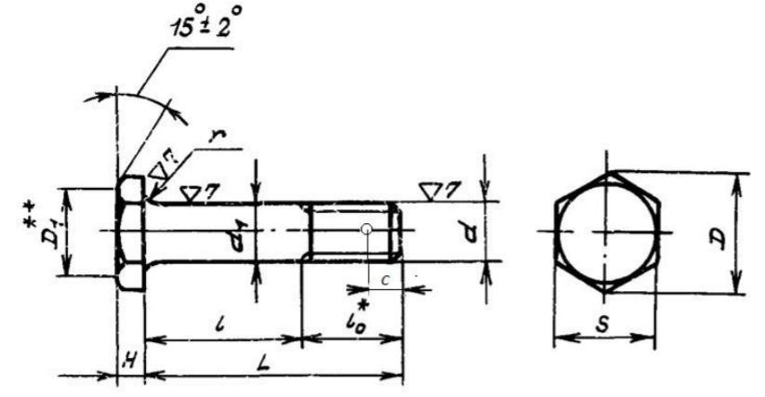

Figure 3.1.2.1 Bolt parameters

According to OST 1 31100-80, we choose a bolt from 30KhGSA with a calculated breaking shear force:

$$\left[{P_{ср}}_{ }\right]≥87500 Н;$$

According to this condition, a bolt with a shaft diameter $d=14 мм$ and with a breaking shear load is suitable:

$$\left[{P_{ср}}_{ }\right]=10500 даН=105000 Н;$$

The bolt has the following main parameters:

$d=14 мм$*; $H=4 мм$; $S=19 мм$; $D=21,9 мм$; $D_{1}=25 мм$; $l_{0}=16 мм$; $l_{min}=24 мм$; $c=4,5 мм;$*

Let us determine the safety factor for shear forces:

$$η=\frac{[{P_{ср}}_{ }]}{{P_{ср}}_{ }}=\frac{105000 Н}{{87500 Н}_{ }}=1,2≥1$$

The strength condition for the safety factor is fulfilled.

For further calculations, we accept a bolt with $d=14 мм$.

## **3.2 Determination of lug thickness from the condition of crushing strength**

Let us write the condition of crushing strength:

${σ_{см}}_{ }≤[σ_{см}]$, Where

${σ_{см}}_{ }$– acting stresses of crushing;

$[σ_{см}]$– design-destructive crushing stresses.

safety factor:

$$η=\frac{[{σ_{см}}_{ }]}{σ_{см}}≥1;$$

We find the operating stresses of crushing by the formula:

$$σ_{см}=\frac{P_{см}}{F_{см}};$$

For the ear:

$$P_{см}=P=175000 Н;$$

for plug

$$P_{см}=\frac{P}{2}=\frac{175000}{2}=87500 Н;$$

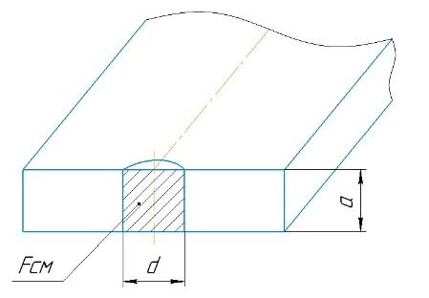

Figure 3.2.1 Sectional sketch of the lug

The crumpled area will be equal to the ear:

$$F_{см}=d∙a;$$

Fork:

$F_{см}=d∙a_{1};$

Then in general:

$$σ_{см}=\frac{P_{см}}{F_{см}}=\frac{P_{см}}{d∙a};$$

The calculated breaking stresses for the lug will be equal to:

$$\left[σ_{см}\right]=K_{см}∙σ_{В};$$

For detachable fixed connection $K_{см}=1$. For the ear from OT4:

$$\left[σ_{см}\right]=σ_{В}=700 МПа;$$

For a plug from 30HGSA :

$$\left[σ_{см}\right]=σ_{В}=1080 МПа;$$

To determine the required thickness of the lug, we equate the effective and computational-destructive collapse stresses :

$$\left[σ_{см}\right]=σ;$$

$$σ=\frac{P_{см}}{d∙a};$$

Then:

$$a=\frac{P_{см}}{d∙σ_{В}};$$

Required eyelet thickness:

$$a=\frac{P_{см}}{d∙σ_{В}}=\frac{175000}{14∙700}=17,85 мм\underset{⇒}{ }a=18 мм;$$

Required fork lug thickness:

$$a_{1}=\frac{P_{см}}{d∙σ_{В}}=\frac{87500}{14∙1080}=5,78 мм\underset{⇒}{ }a_{1}=6 мм$$

Thus, the required thickness a of the eyelet for the ear is 18 mm, and for the eyelet of the fork - 6 mm.

Now we determine the effective collapse stresses:

For the ear:

$$σ_{см}=\frac{P_{см}}{d∙a}=\frac{175000}{14∙18}=694 МПа;$$

Fork:

$$σ_{см}=\frac{P_{см}}{d∙a_{1}}=\frac{87500}{14∙6}=1041,7 МПа;$$

Let's determine the safety factor for the ear and fork. For the ear:

$$η=\frac{700}{694}=1,01≥1;$$

Fork:

$$η=\frac{1080}{1041,7}=1,04≥1$$

*The strength condition is satisfied.*

## **3.3 Bolted connection parameters**

Determine the length of the bolt:

$$L=δ_{пак}+δ_{шайбы}+δ_{гайки};$$

The thickness of the contracted package is equal to:

$$δ_{пак}=a+2∙a_{1}=18+2∙6=30 мм$$

We will use a low self-locking hex nut . According to OST 1 33048-80, we select a nut from steel 30KhGSA. Thread - M14x1.5. Nut height H – 11.5 mm. Turnkey size S - 19 mm. Head diameter D =21.1 mm. Designation - Nut 14-Kd- OST 1 33048-80.

We will also take the washer from steel 30KhGSA according to OST 1 34507-80. Its height S = 2 mm, $d_{1}=15 мм$, $d_{2}=28 мм$. Designation - Washer 2-14-20-Kd OST 1 34507-80.

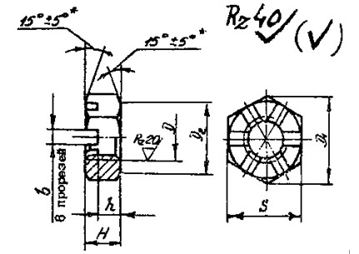 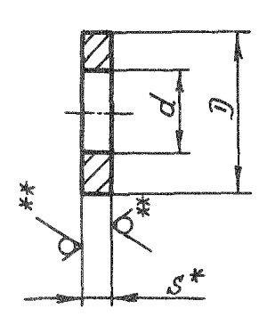

Figure 3.3.1 Washer and nut

Taking into account the protruding threaded part of the bolt from the nut and its chamfer (according to the design rules, the threaded part of the bolt should protrude from the nut by 1-2 turns), then add the following value in addition to the bolt size:

$Δl=1,5*2+1,5=4,5 мм;$

Thus, the required bolt length will be equal to:

$$L=30+11,5+2+3=48 мм$$

There is a standard bolt length according to OST 1 31132-80 48 mm.

So, we will use Bolt 14-42-Kd-OST 1 31132-80.

## **3.4 Determining the dimensions ( x , y , b ) of the lugs from the tensile strength condition**

We define the eyelet parameters - x , y , b .

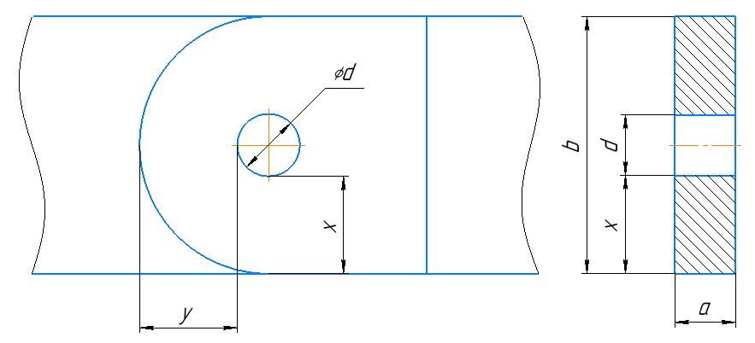

Figure 3.4.1 Eyelet parameters

Let us write down the tensile strength condition:

${σ_{разр}}_{ }≤[σ_{разр}]$, Where

${σ_{разр}}_{ }$– acting stresses of discontinuity;

- design-destructive rupture stresses.

We find the effective discontinuity stresses by the formula:

$$σ_{разр}=\frac{P_{разр}}{F_{разр}}$$

For the ear:

$$P_{разр}=P=175000 Н;$$

Fork:

$$P_{разр}=\frac{P}{2}=\frac{175000}{2}=87500 Н;$$

The area of the gap will be equal to:

For the ear:

$F_{разр}=\left(b-d\right)∙a=2∙a∙x$ (because ) $b=2∙x+d$;

Fork:

$$F_{разр}=\left(b-d\right)∙a_{1}=2∙a_{1}∙x;$$

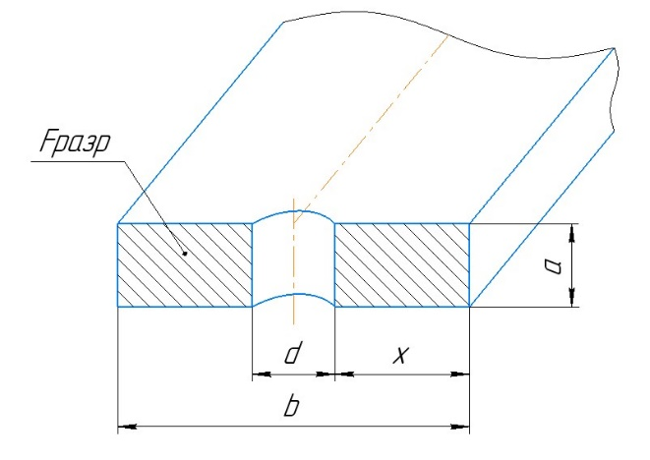

Figure 3.4.2 Sectional sketch of eyelet

Then in general:

$$σ_{разр}=\frac{P_{разр}}{F_{разр}}=\frac{P_{разр}}{\left(b-d\right)∙a}=\frac{P_{разр}}{2∙a∙x}$$

The design-destructive stresses will be equal to:

$$\left[σ_{разр}\right]=K_{разр}∙σ_{В};$$

The coefficient $K_{разр}$ is determined by the formula:

$K_{разр}=0,565+0,48∙\frac{y}{x}-0,1∙\frac{b}{d}$, Where

- eyelet width.

For a fixed connection, we accept $\frac{y}{x}=1,4$, $\frac{b}{d}=2$.

Then the coefficient will be equal to:

$$K_{разр}=0,565+0,48∙1,4-0,1∙2=1,037;$$

Since $K_{разр}=1,037≥1$, we accept $K_{разр}=1$.

Means:

$$\left[σ_{разр}\right]=σ_{В};$$

Let us express the distance *x* for the ear by substituting the obtained dependencies into the previously recorded tensile strength condition:

$$\frac{P_{разр}}{2∙a∙x}=σ_{В};$$

$$x=\frac{P_{разр}}{2∙a∙σ_{В}};$$

Substitute our values into the formula:

$$x=\frac{P_{разр}}{2∙a∙σ_{В}}=\frac{175000}{2∙18∙700}=6,94 мм\underset{⇒}{ }x=7 мм;$$

Then according to the accepted relations:

$$y=1,4∙x=1,4∙7=9,8 мм \underset{⇒}{ }y=10 мм$$

Eyelet Width:

$$b=2∙x+d=2∙7+14=28 мм$$

The value of the *x* dimension for the fork eyelet is determined in the same way:

$$x=\frac{P_{разр}}{2∙a_{1}∙σ_{В}}=\frac{87500}{2∙6∙1080}=6,75 мм\underset{⇒}{ }7 мм$$

Then according to the accepted relations:

$$y=1,4∙x=1,4∙7=9,8 мм \underset{⇒}{ }10 мм$$

Eyelet Width:

$$b=2∙x+d=2∙7+14=28 мм$$

We choose the same design parameters for both lugs:

$x=7 мм$;

$y=10 мм$*;*

$b=28 мм$*;*

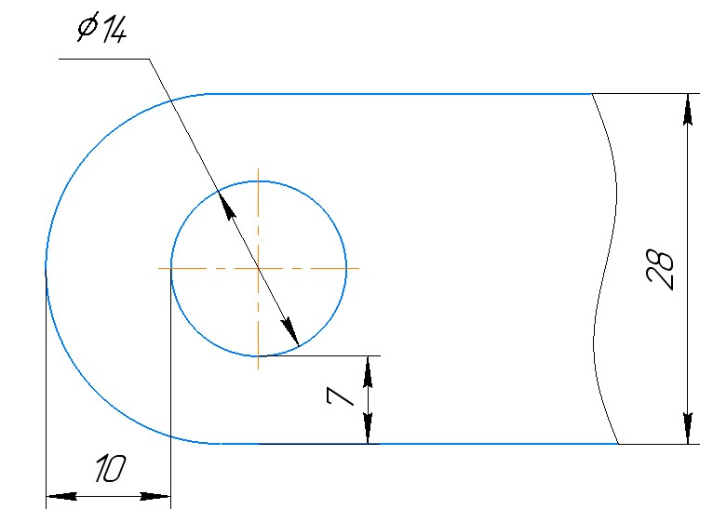

Figure 3.4.3 Accepted lug parameters

Let's determine the safety factor:

$$η=\frac{[{σ_{разр}}_{ }]}{σ_{разр}}≥1$$

Design-destructive stresses:

$$\left[σ_{разр}\right]=σ_{В};$$

For the ear:

$$\left[σ_{разр}\right]=700 МПа;$$

Fork:

$$\left[σ_{разр}\right]=1080 МПа;$$

Acting discontinuity stresses in the ear lugs:

$$σ_{разр}=\frac{P_{разр}}{F_{разр}}=\frac{P_{разр}}{\left(b-d\right)∙a}=\frac{175000}{\left(28-14\right)∙18}=694 МПа;$$

Effective breaking stresses in the fork lugs:

$$σ_{разр}=\frac{P_{разр}}{F_{разр}}=\frac{P_{разр}}{\left(b-d\right)∙a}=\frac{87500}{\left(28-14\right)∙6}=1041,7 МПа;$$

Then, the safety factor for the ear will be equal to: $$η=\frac{694 МПа}{700 МПа}=1,01≥1;$$

Fork:

$$η=\frac{1080 МПа}{1041,7 МПа}=1,04≥1;$$

The tensile strength condition is met.

## **3.5 Checking the shear strength of the lugs**

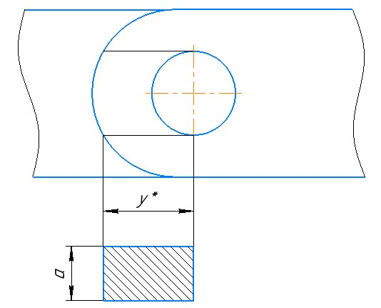

Figure 3.5.1 Lug cutting plane

We write down the condition of strength when cutting the eyelet:

$τ_{ср}≤[τ_{ср}]$, Where

$τ_{ср}$ are the effective shear stresses;

$[τ_{ср}]$– design-destructive shear stresses.

Margin of safety for shear stresses:

$$η=\frac{[{τ_{ср}}_{ }]}{{τ_{ср}}_{ }}≥1;$$

The effective shear stresses are determined by the formula:

$$τ_{ср}=\frac{P_{ср}}{F_{ср}}=\frac{P_{ср}}{2∙a∙y^{*}};$$

For the ear:

$$P_{ср}=P=175000 Н;$$

Fork:

$$P_{ср}=\frac{P}{2}=\frac{175000}{2}=87500 Н;$$

The cut area of the ear will be equal to:

$$F_{ср}=2∙a∙y^{*};$$

Fork:

$$F_{ср}=2∙a_{1}∙y^{*};$$

We will take the distance from the drawing: $y^{*}$

$$y^{*}≈15,1 мм;$$

Effective cutoff voltages for the ear:

$$τ_{ср}=\frac{P_{ср}}{2∙a∙y^{*}}=\frac{175000}{2∙18∙15,1}=321,9 МПа;$$

For plug:

$$τ_{ср}=\frac{P_{ср}}{2∙a_{1}∙y^{*}}=\frac{87500}{2∙6∙15,1}=482,9 МПа;$$

The design-destructive shear stresses will be equal to the tensile strength for shear stresses:

$\left[τ_{ср}\right]=τ_{В}$, Where

Let us determine the coefficients of safety factor at shear. For the ear:

$$η=\frac{[{τ_{ср}}_{ }]}{{τ_{ср}}_{ }}=\frac{350}{{321,9}_{ }}=1,09≥1;$$

Fork:

$$η=\frac{[{τ_{ср}}_{ }]}{{τ_{ср}}_{ }}=\frac{648}{482,9}=1,34≥1;$$

The shear strength condition is met.

## **3.6 Design parameters**

**ear eye**

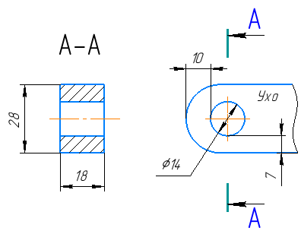Material: OT4;

$a=18 мм$*;*

$x=7 мм$*;*

$y=10 мм$*;*

$b=28 мм$*;*

$d=14 мм$*;*

**fork lug**

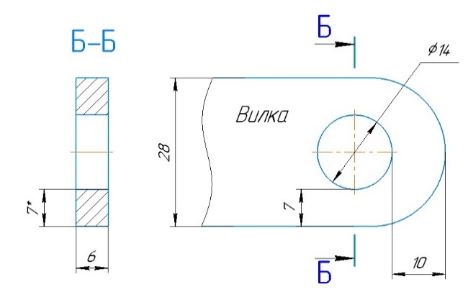Material: 30HGSA;

$a_{1}=6 мм$*;*

$x=7 мм$*;*

$y=10 мм$*;*

$b=28 мм$*;*

$d=14 мм$*;*

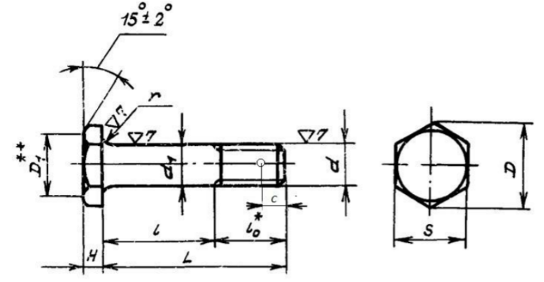**Bolt**

Material: 30HGSA;

OST 1 31132-80 "Bolts with a reduced hexagonal head with a tolerance field for the diameter of the rod h 8 and a short threaded part."

Bolt 14-48-Kd-OST 1 31132-80;

$d=14 мм$*; $H=4 мм$; $S=19 мм$; $D=21,9 мм$; $l_{0}=16 мм$; $L=40 мм$; $l=22 мм;$*

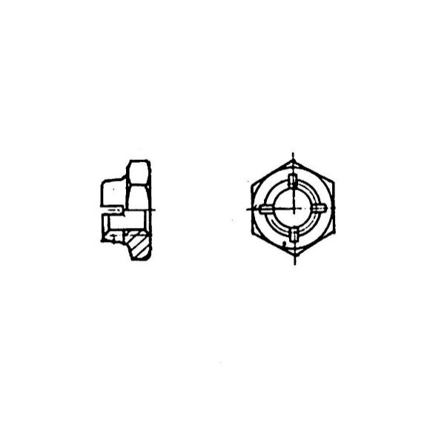**Screw:**

Material: 30HGSA;

OST 1 33067-80 "Low hexagon slotted nuts";

Nut 14-Kd OST 1 33048-80;

$D=M14х1,5$, $H=11,5 мм$, $S=19 мм$, $D_{1}=21,1 мм$, $D_{2}=18 мм$, $h=5,1 мм$, $b=3 мм;$

**Washer:**

Material: 30HGSA;

OST 1 34507-80 "Washers";

Washer 2-14-20-Kd OST 1 34507-80;

$d_{1}=15 мм$, $d_{2}=28 мм$, S =2 mm.

# **4. Calculation of the movable connection (with bushings)**

Let's calculate the mobile connection.

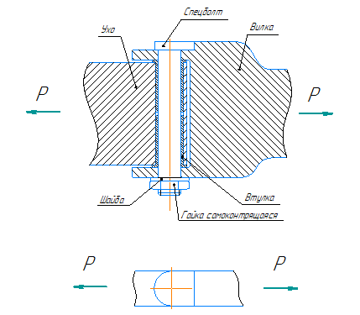

Figure 4.1 Scheme of a mobile connection

## **Features of the mobile connection**

1. One of the eyes of the movable (non-movable) connection must be fixedly connected to the bolt.

2. In this version, the fork lug is permanently connected to the bolt, as it is connected to a special bolt head. The design parameters of the fork eye are obtained in the calculation of a fixed connection.

3. Mobility is provided by the rotation of the ear lug relative to the bolt. The lug has two bushings.

4. The diameter of the special bolt is determined in the calculation of the fixed connection. The shank of the bolt is made with tolerance f7 as an articulated one.

The diameter of the special bolt will be the same as for the fixed connection. Those. it will be equal to d \u003d 14 mm according to the strength conditions (see the calculation of the fixed connection). Bolt material - steel 30HGSA, bushings - 30HGSA

Plug parameters based on fixed connection:

$a_{1}=6 мм$*; $x=7 мм$; $y=10 мм$; $b=28 мм$; $d=14 мм$;*

## **4.1 Determining the thickness of the eyelet from the condition of crushing strength**

The thickness of the ear ear is determined based on two factors:

1) collapse along the inner diameter *d* of the bushing;

2) collapse along the outer diameter *D* bushings;

Bushing material - steel 30HGSA

Effective crushing force:

$$P_{см}=175000 Н;$$

Eyelet thickness:

$a=2∙L_{вт}+2 мм$,

where 2 is the gap between the bushings.

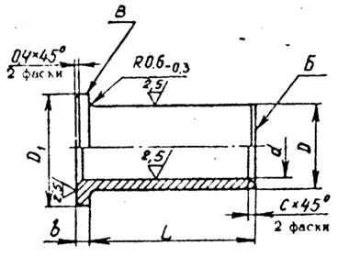

Figure 4.1.1 Geometric dimensions of the sleeve

### **4.1.1 According to the inner diameter d (collapse of the bushing by the bolt)**

Let us write the condition of crushing strength:

${σ_{см}}_{ }≤[σ_{см}]$, Where

${σ_{см}}_{ }$– acting stresses of crushing;

$[σ_{см}]$– design-destructive crushing stresses.

safety factor:

$$η=\frac{[{σ_{см}}_{ }]}{σ_{см}}≥1;$$

We find the operating stresses of crushing by the formula:

$$σ_{см}=\frac{P_{см}}{F_{см}};$$

For the ear:

$P_{см}=P=175000 Н$.

The crumpled area for the ear will be equal to:

$F_{см}=2∙d∙(L_{вт}+b)$*,* where

- sleeve length;

- bead height.

Then in general:

$$σ_{см}=\frac{P_{см}}{F_{см}}=\frac{P_{см}}{2∙d∙(L_{вт}+b)};$$

The calculated breaking stresses for the bushing will be equal to:

$$\left[σ_{см}\right]=K_{см}∙σ_{В};$$

For mobile connection $K_{см}=0,2.$

Then the calculated breaking stresses for the bushing made of 30KhGSA :

$$\left[σ_{см}\right]=0,2∙1080=216 МПа;$$

To determine the required height of the bushing, we equate the effective and design-destructive collapse stresses:

$$σ_{см}=\left[σ_{см}\right];$$

$$\left[σ_{см}\right]=\frac{P_{см}}{2∙d∙(L_{вт}+b)};$$

$$\left(L_{вт}+b\right)=\frac{P_{см}}{2∙d∙\left[σ_{см}\right]}=\frac{175000}{2∙14∙216}=28,93 мм;$$

In the tulka we will choose according to the table OST 1 11127-73. Sleeve material - 30HGSA. We choose a sleeve with a length of 30 mm.

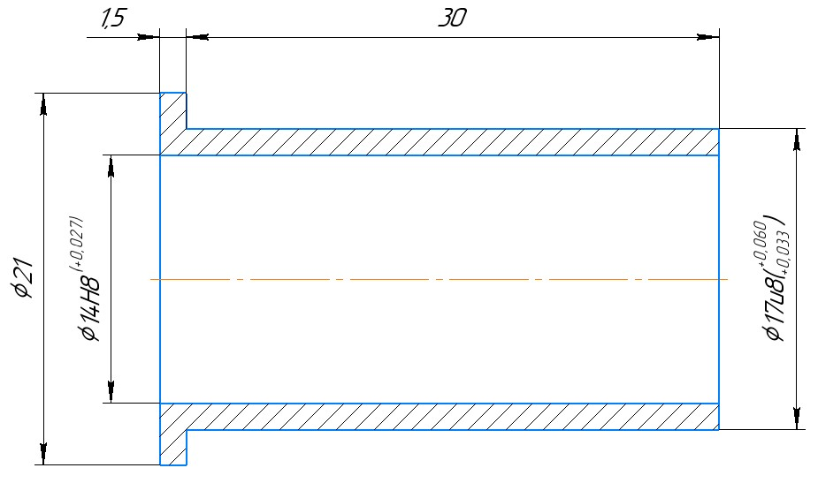

Figure 4.1.1.1 Selected sleeve

$L_{вт}=30 мм$; $D=17 мм$; $D_{1}=21 мм$; $D=17 мм$; $b=1,5 мм$

Then the thickness of the ear will be equal to:

$$a=2∙L_{вт}+2=2∙30+2=62 мм$$

Let us determine the effective bearing stresses:

$$σ_{см}=\frac{P_{см}}{F_{см}}=\frac{P_{см}}{2∙d∙(L_{вт}+b)}=\frac{175000}{2∙14∙(30+1,5)}=198,4 МПа;$$

Then, the safety factor for the bushing is:

$$η=\frac{[{σ_{см}}_{ }]}{σ_{см}}=\frac{216 МПа}{198,4 МПа}=1,09≥1$$

The strength condition is satisfied.

### **4.1.2 According to the outer diameter D (collapse of the eye by the sleeve)**

Let us write the condition of crushing strength:

${σ_{см}}_{ }≤[σ_{см}]$, Where

${σ_{см}}_{ }$– acting stresses of crushing;

$[σ_{см}]$– design-destructive crushing stresses.

safety factor:

$$η=\frac{[{σ_{см}}_{ }]}{σ_{см}}≥1;$$

We find the operating stresses of crushing by the formula:

$$σ_{см}=\frac{P_{см}}{F_{см}};$$

$P_{см}=P_{ср};$

For the ear:

$$P_{см}=P_{ср}=P=175000 Н;$$

The crumpled area for the ear will be equal to:

$F_{см}=2∙D∙L_{вт}$, Where

- sleeve length;

$D$ is the outside diameter of the bushing.

The calculated breaking stresses for the lug will be equal to:

$$\left[σ_{см}\right]=K_{ }∙σ_{В};$$

Because the connection of the bushings with the ear eye is fixed (the bushing is pressed in), then we take the coefficient K = 1.

Then the calculated breaking stresses for the ear from OT4 :

$$\left[σ_{см}\right]=σ_{B}=700 МПа;$$

Let us equate the effective and design-destructive crushing stresses and substitute the obtained dependencies into the expression for the effective stresses and express the required lug thickness as the sum of two bushing lengths and a gap of 2 mm between them:

$$a=2∙L_{вт}+2;$$

$$σ_{см}=\frac{P_{см}}{F_{см}}=\frac{P_{см}}{2∙D∙L_{вт}}=\left[σ_{см}\right]=σ_{B} \underset{⇒}{ } L_{вт}=\frac{P_{см}}{2∙D∙σ_{B}};$$

$$L_{вт}=\frac{175000}{2∙17∙700}=7,35 мм\underset{⇒}{ }8 мм;$$

Then the required thickness of the ear will be equal to:

$$a=2∙8+2=18 мм;$$

Let us determine the effective bearing stresses:

$$σ_{см}=\frac{P_{см}}{F_{см}}=\frac{P_{см}}{2∙D∙L_{вт}}=\frac{175000}{2∙17∙8}=643 МПа;$$

Then, the safety factor for the ear is:

$$η=\frac{[{σ_{см}}_{ }]}{σ_{см}}=\frac{700 МПа}{643 МПа}=1,09≥1$$

The strength condition is satisfied.

Of the two options, choose the largest eye thickness. Then:

$$a=62 мм.$$

## **4.2 Bolted connection parameters**

Determine the length of the special bolt :

$$L=δ_{пак}+δ_{шайбы}+δ_{гайки};$$

The thickness of the contracted package is equal to:

$$δ_{пак}=a+2∙a_{1}+2∙b=62+2∙6+2∙1,5=77 мм$$

We will use a low self-locking hex nut . We will choose the nut according to OST 1 33067-80. Nut material - 30HGSA. Thread - M14x1.5. Nut height H – 11.5 mm. Turnkey size S - 19 mm. Head diameter D =21.1 mm. Designation - Nut 14-Kd-OST 1 33067-80.

We will also take the washer from steel 30KhGSA according to OST 1 34507-80. Its height S = 2 mm, $d_{1}=15 мм$, $d_{2}=28 мм$. Designation - Washer 2-14-20-Kd OST 1 34507-80.

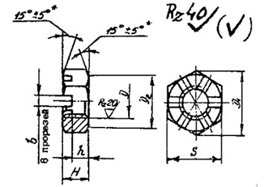 

Figure 4.2.1 Nut and Washer Options

Taking into account the protruding threaded part of the bolt from the nut and its chamfer (according to the design rules, the threaded part of the bolt should protrude from the nut by 1-2 turns), then add in addition to the size of the bolt:

$$1,5*2+1,5=4,5 мм;$$

Thus, the required length of the special bolt will be equal to:

$$L=77+11,5+2+4,6=95 мм;$$

## **4.3 Determining the dimensions ( x , y , b ) of the ear lug from the tensile strength condition**

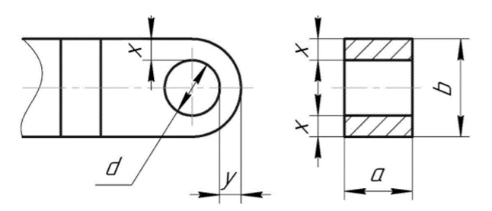

Figure 4.3.1 Ear lug design parameters

Let us write down the tensile strength condition:

${σ_{разр}}_{ }≤[σ_{разр}]$, Where

${σ_{разр}}_{ }$– acting stresses of discontinuity;

- design-destructive rupture stresses.

safety factor:

$$η=\frac{[{σ_{разр}}_{ }]}{σ_{разр}}≥1$$

We find the effective discontinuity stresses by the formula:

$$σ_{разр}=\frac{P_{разр}}{F_{разр}};$$

For the ear:

$$P_{разр}=P=175000 Н;$$

The gap area for the ear will be equal to:

$F_{разр}=\left(b-D\right)∙a=2∙a∙x;$

The design-destructive stresses will be equal to:

$$\left[σ_{разр}\right]=K_{разр}∙σ_{В};$$

The coefficient $K_{разр}$ is determined by the formula:

$K_{разр}=0,565+0,48∙\frac{y}{x}-0,1∙\frac{b}{d}$, Where

- eyelet width.

For a mobile connection, we will accept $\frac{y}{x}=1$, $\frac{b}{d}=2$.

Then the coefficient will be equal to:

$$K_{разр}=0,565+0,48∙1-0,1∙2=0,845;$$

Hence, the design-destructive stresses for the ear:

$$\left[σ_{разр}\right]=K_{разр}∙σ_{В}=0,845∙700=591,5 МПа$$

Let us express the size *x* for the fork by substituting the obtained dependencies into the previously written tensile strength condition:

$$\frac{P_{разр}}{2∙a∙x}=K_{разр}∙σ_{В};$$

$$x=\frac{P_{разр}}{2∙a∙K_{разр}∙σ_{В}};$$

Substitute our values into the formula:

$$x=\frac{P_{разр}}{2∙a∙K_{разр}∙σ_{В}}=\frac{175000}{2∙62∙0,845∙700}=2,38 мм\underset{⇒}{ }x=3 мм;$$

Then according to the accepted relations:

$$y=1∙x=1∙3=3 мм;$$

From constructive considerations, we accept:

$$x=y=5 мм.$$

Eyelet Width:

$$b=2∙x+D=2∙3+17=23 мм;$$

As a result, the effective discontinuity stresses in the ear lugs:

$$σ_{разр}=\frac{P_{разр}}{F_{разр}}=\frac{P_{разр}}{\left(b-D\right)∙a}=\frac{175000}{\left(23-17\right)∙62}=470 МПа;$$

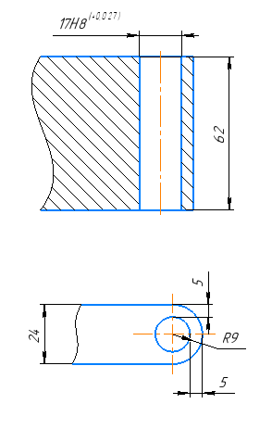

Figure 4.3.2 Selected ear lug design parameters

Then, the safety factor for the ear will be equal to: $$η=\frac{[{σ_{разр}}_{ }]}{σ_{разр}}=\frac{591,5}{470}=1,26≥1;$$

The tensile strength condition is met.

## **4.4 Checking the shear strength of the lug**

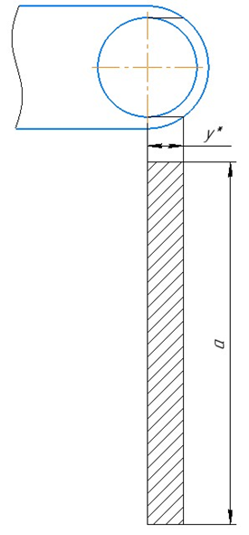

Figure 4.4.1 Plane of action of maximum shear stresses

We write down the condition of strength when cutting the eyelet:

$τ_{ср}≤[τ_{ср}]$, Where

$τ_{ср}$ are the effective shear stresses;

$[τ_{ср}]$– design-destructive shear stresses.

Margin of safety for shear stresses:

$$η=\frac{[{τ_{ср}}_{ }]}{{τ_{ср}}_{ }}≥1;$$

The effective shear stresses are determined by the formula:

$$τ_{ср}=\frac{P_{ср}}{F_{ср}}=\frac{P_{ср}}{2∙a∙y^{*}};$$

For the ear:

$$P_{ср}=P=175000 Н;$$

The cut area will be equal to the ear:

$$F_{ср}=2∙a∙y^{*};$$

We will take the distance from the drawing: $y^{*}$

$$y^{*}≈9,7 мм;$$

Effective cutoff voltages for the ear:

$$τ_{ср}=\frac{P_{ср}}{2∙a∙y^{*}}=\frac{175000}{2∙62∙9,7}=145,5 МПа;$$

The design-destructive shear stresses will be equal to:

$$\left[τ_{ср}\right]=τ_{В}=350 МПа;$$

Let us determine the safety factors for the cut for the ear:

$$η=\frac{[{τ_{ср}}_{ }]}{{τ_{ср}}_{ }}=\frac{350}{{145,5}_{ }}=2,4≥1;$$

The shear strength condition is met.

## **4.5 Design parameters**

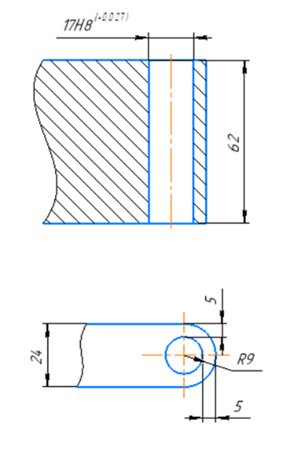**ear eye**

Material: OT4;

$a=62 мм$*;*

$x=5 мм$*;*

$y=5 мм$*;*

$b=23 мм$*;*

$d=17 мм$*;*

**fork lug**

**Material: 30HGSA;

$a_{1}=6 мм$*;*

$x=7 мм$*;*

$y=10 мм$*;*

$b=28 мм$*;*

$d=14 мм$*;*

*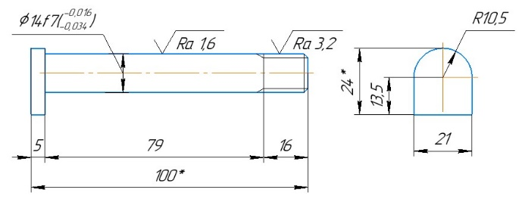***special bolt**

Material: 30HGSA;

$d=М14$*;*

$H=5 мм$*;*

$l_{0}=14,5 мм$*;*

$L=108,5 мм$*;*

$l=89 мм$*.*

**Screw:**

Material: 30HGSA

OST 1 33067-80 "Hexagon low self-locking nuts ";

Nut 14-Kd-OST 1 33067-80;

$D=M14х1,5$, $H=11,5 мм$, $S=19 мм$, $D_{1}=21,1 мм$, $D_{2}=18 мм$, $h=5,1 мм$, $b=3 мм.$

**Washer:**

Material: 30HGSA;

OST 1 34507-80 "Washers";

Washer 2-14-20-Kd OST 1 34507-80;

$d_{1}=15 мм$, $d_{2}=28 мм$, S =2 mm.

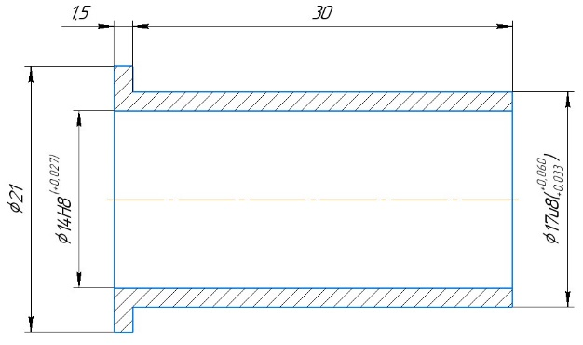**Sleeve:**

Material: 30HGSA;

OST 1 11127-73 "Bushes with collar for pressing";

$L_{вт}=30 мм$; $D=17 мм$; $b=1,5 мм$; $D_{1}=21 мм$;

$d=14 мм.$

# **5. Summary table of safety factors**

Tab. 5.1 "Safety factors of structural elements"

|  |  |  |  |
| --- | --- | --- | --- |
| **Element** | **Type of destruction** | **Condition**  **strength** | **stock**  **strength** |
| ***Fixed connection*** | | | |
| Bolt | slice | $$τ_{ср}≤[τ_{ср}]$$ | $$η=\frac{[{τ_{ср}}_{ }]}{{τ_{ср}}_{ }}=1,2$$ |
| ear eye | Collapse | $${σ_{см}}_{ }≤[σ_{см}]$$ | $η=\frac{[{σ_{см}}_{ }]}{σ_{см}}=$ 1.01 |
| Gap | $${σ_{разр}}_{ }≤[σ_{разр}]$$ | $$η=\frac{[{σ_{разр}}_{ }]}{σ_{разр}}=1,01$$ |
| slice | $$τ_{ср}≤[τ_{ср}]$$ | $$η=\frac{[{τ_{ср}}_{ }]}{{τ_{ср}}_{ }}=1,09$$ |
| fork lug | Collapse | $${σ_{см}}_{ }≤[σ_{см}]$$ | $$η=\frac{[{σ_{см}}_{ }]}{σ_{см}}=1,04$$ |
| Gap | $${σ_{разр}}_{ }≤[σ_{разр}]$$ | $$η=\frac{[{σ_{разр}}_{ }]}{σ_{разр}}=1,04$$ |
| slice | $$τ_{ср}≤[τ_{ср}]$$ | $$η=\frac{[{τ_{ср}}_{ }]}{{τ_{ср}}_{ }}=1,34$$ |
| ***Mobile connection*** | | | |
| Bolt | slice | $$τ_{ср}≤[τ_{ср}]$$ | $$η=\frac{[{τ_{ср}}_{ }]}{{τ_{ср}}_{ }}=1,21$$ |
| ear eye | Collapse in d | $${σ_{см}}_{ }≤[σ_{см}]$$ | $$η=\frac{[{σ_{см}}_{ }]}{σ_{см}}=1,09$$ |
| Collapse in D | $${σ_{см}}_{ }≤[σ_{см}]$$ | $$η=\frac{[{σ_{см}}_{ }]}{σ_{см}}=1,09$$ |
| Gap | $${σ_{разр}}_{ }≤[σ_{разр}]$$ | $$η=\frac{[{σ_{разр}}_{ }]}{σ_{разр}}=1,26$$ |
| slice | $$τ_{ср}≤[τ_{ср}]$$ | $$η=\frac{[{τ_{ср}}_{ }]}{{τ_{ср}}_{ }}=2,4$$ |
| fork lug | Collapse | $${σ_{см}}_{ }≤[σ_{см}]$$ | $$η=\frac{[{σ_{см}}_{ }]}{σ_{см}}=1,04$$ |
| Gap | $${σ_{разр}}_{ }≤[σ_{разр}]$$ | $$η=\frac{[{σ_{разр}}_{ }]}{σ_{разр}}=1,04$$ |
| slice | $$τ_{ср}≤[τ_{ср}]$$ | $$η=\frac{[{τ_{ср}}_{ }]}{{τ_{ср}}_{ }}=1,34$$ |

# **6. List of used literature**

1) T.M. Avdyukhina , I.M. Alyavdin, V.V. Vasiliev, A.F. Kolganov, A.A. Krasotkin , V.V. Malchevsky , V.I. Reznichenko, A.N. Stepanov, I.A. Shatalov "Designing Aircraft Parts: Textbook for Course Design" - M .: MAI Publishing House, 1993

2) A.V. Leshchin, Yu.I. Popov "Designing Airframe Units: Textbook for Course Design" / ed. Yu.I. Popova - M.: MAI Publishing House, 1992

3) A.I. Endogur Aircraft Design. Design of parts and assemblies "- M .: MAI Publishing House, 2013